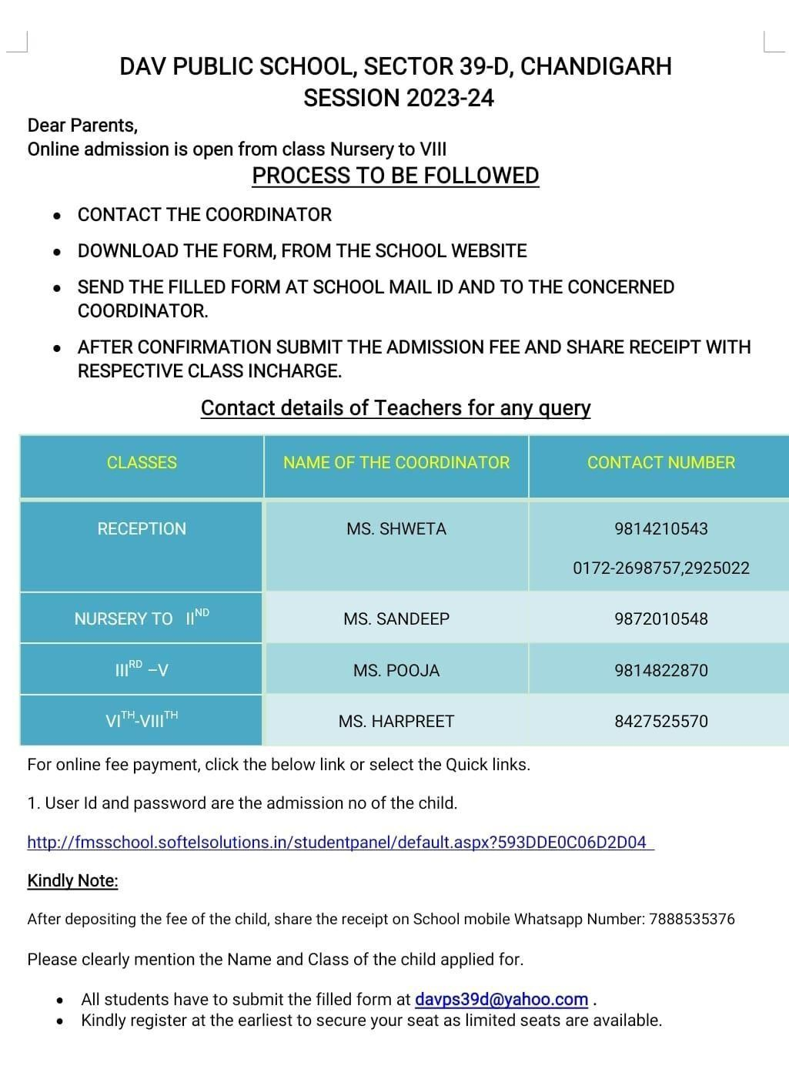

**SESSION:2024-2025**

Classes

Reception

MS. SHVETA

Nursery to 2nd

3rd to 5th

6th to 8th